ADITHYA R
192311369

Experiment – 19
Question: Demonstrate Infrastructure as a Service (IaaS) by creating a Virtual Machine using a Public
Cloud Service Provider (Azure), configure with required memory and CPU.
Answer:
AIM: To demonstrate Infrastructure as a Service (IaaS) by creating and configuring a Virtual Machine (VM) with required CPU and memory using Microsoft Azure.
SOFTWARE REQUIRED:
- Microsoft Azure Account (Free Trial / Student Subscription)
- Web Browser (Google Chrome / Microsoft Edge)
- Stable Internet Connection
- Azure Portal (https://portal.azure.com)
Procedure:
STEP 1: Login to Azure Portal
- Open a web browser.
- Navigate to https://portal.azure.com
- Sign in with Azure credentials.

STEP 2: Create a Virtual Machine
- In the Azure Portal search bar, type Virtual Machines.
- Click + Create → Select Azure Virtual Machine.

STEP 3: Configure Basic Details
Fill in the required details:
- Subscription: Select your subscription
- Resource Group: Create new → IaaS-VM-RG
- Virtual Machine Name: IaaS-Demo-VM
- Region: Choose nearest region (e.g., Central India)
- Image: Ubuntu Server 22.04 LTS (or Windows Server 2022)

STEP 4: Configure Required CPU and Memory
Click Size → See all sizes and select the required configuration.
Example Configurations:
VM Size | CPU | RAM
Standard B1s | 1 vCPU | 1 GB
Standard B2s | 2 vCPU | 4 GB
Standard D2s v3 | 2 vCPU | 8 GB
Select the required VM size as per experiment requirement.

STEP 5: Administrator Account
For Linux:
- Authentication type: Password
- Username: azureuser
- Password: Create strong password
For Windows:
- Username & Password required

STEP 6: Configure Storage
- OS Disk Type: Standard SSD
- Disk Size: Default (30 GB or as required)

STEP 7: Configure Networking
- Allow Public inbound ports:
  - Select SSH (22) for Linux
  - Select RDP (3389) for Windows
Click Review + Create → Create
⏳ Deployment takes 2–5 minutes.

STEP 8: Verify the Virtual Machine
- Go to Virtual Machines → Select IaaS-Demo-VM
- Check VM status (Running)
- Click Connect
  - Use SSH (Linux)
  - Use RDP (Windows)
Successfully access the virtual machine.

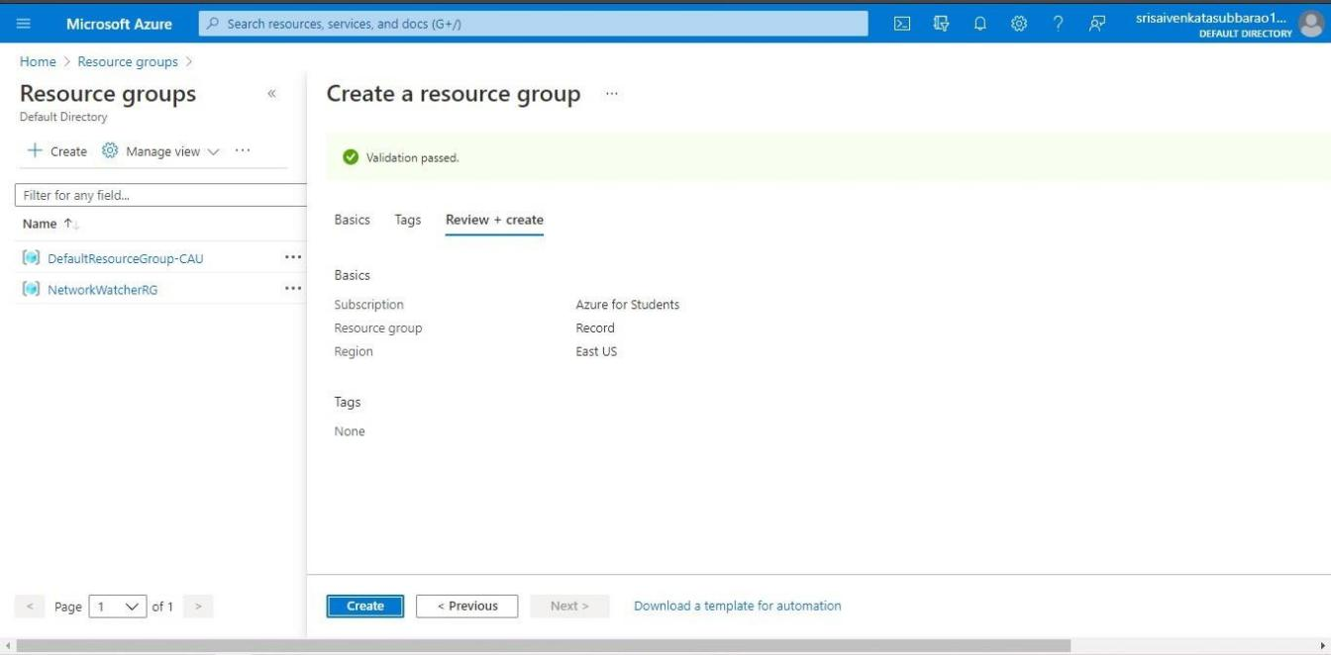

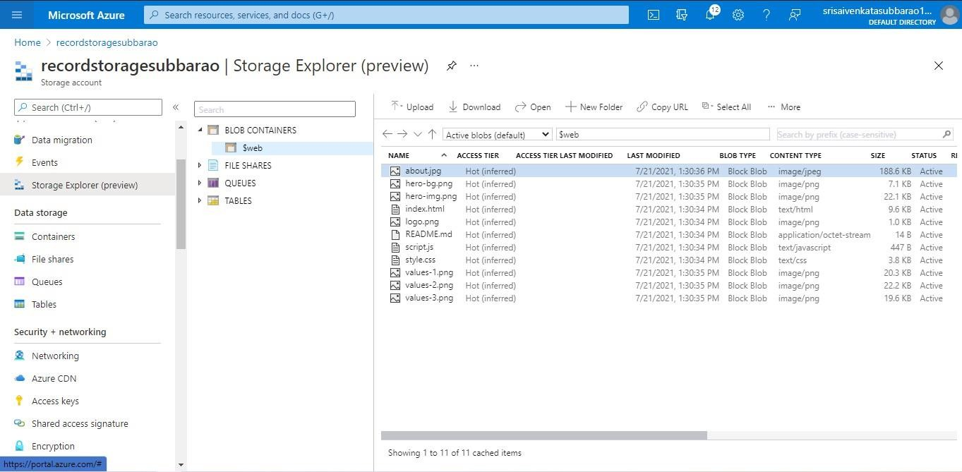

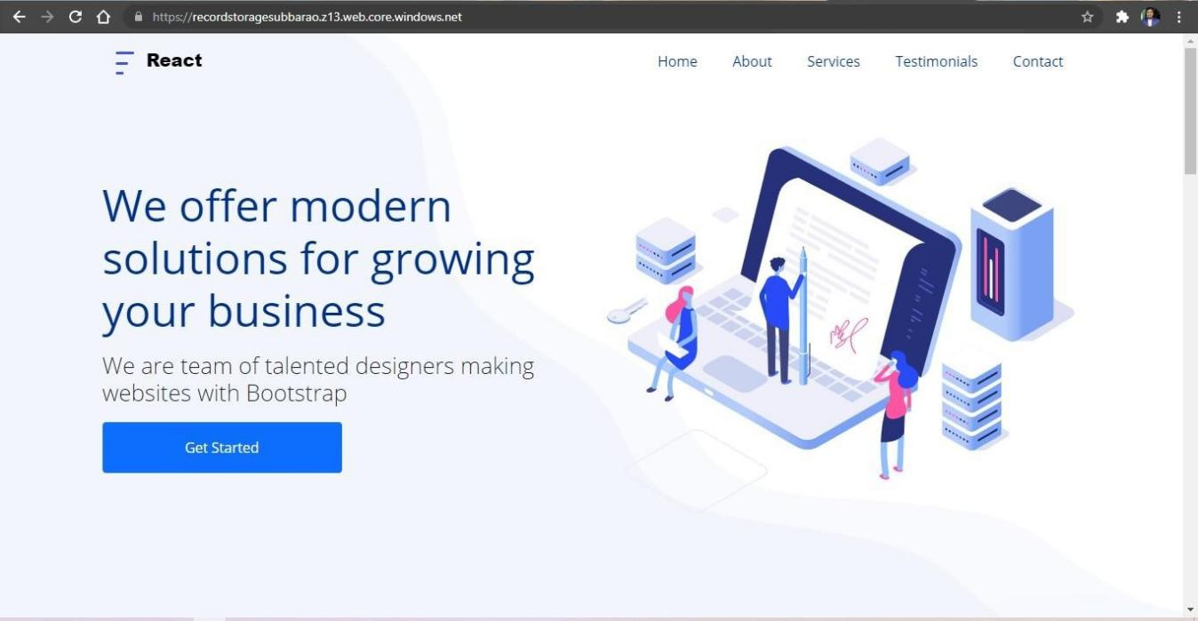

RESULT:
The Virtual Machine was successfully created and configured with the required CPU and memory using Microsoft Azure.
Thus, Infrastructure as a Service (IaaS) was successfully demonstrated by provisioning and managing virtual computing resources in the Azure cloud environment.

